Network Manager Connect (Option 1) Phishing Testing Lab (Wifiphisher)
Complete Guide
Prerequisites
- Operating System: Kali Linux
- Tools: Wifiphisher installed
- Hardware: Wireless adapter capable of both Monitor Mode and Access Point (AP) mode.

Step 1: Launching Wifiphisher and Selecting the WiFi
- Open your terminal.
- Run the Wifiphisher command: sudo wifiphisher
- Wait for the scanning process to finish and the list of nearby networks to populate.
- Use the Up and Down arrow keys to highlight the target network (in this lab, lab test wifi).
- Press Enter to select the target.
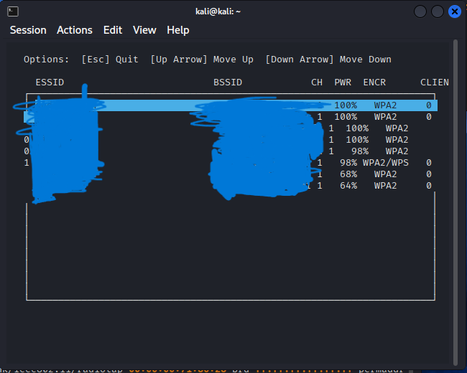

Step 2: Selecting the Network Manager Scenario
- After selecting the target, Wifiphisher will present a menu of phishing scenarios.
- Use the arrow keys to navigate and select Option 1: Network Manager.
- Press Enter.
- Wifiphisher will now automatically create an "Evil Twin" access point (copying the exact SSID of the target) and will begin sending deauthentication packets to disconnect the victim from the real network, forcing them to join the fake one.
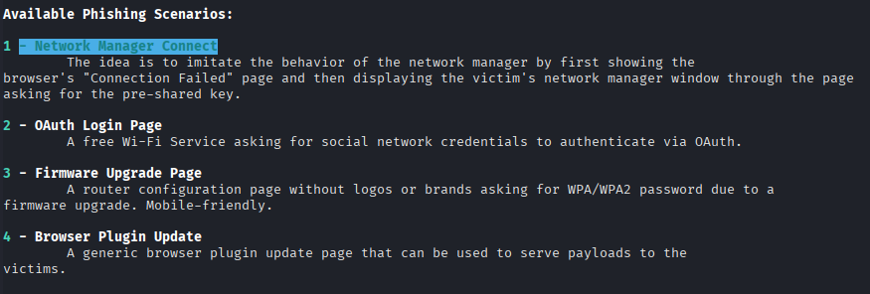

Step 3: The Victim's Perspective (Network Manager Prompt)
- The victim's device is kicked off the real network.
- When they try to reconnect, they are automatically connected to the Evil Twin.
- Wifiphisher serves a highly convincing fake "Network Manager" pop-up window. Unlike the browser-based attacks, this mimics the actual operating system's Wi-Fi connection dialog (often styled to look like Windows or macOS).
- The pop-up states that the network requires re-authentication or that the connection failed.
- The victim is prompted to enter their WPA2 Pre-Shared Key to "connect" to the network before use.
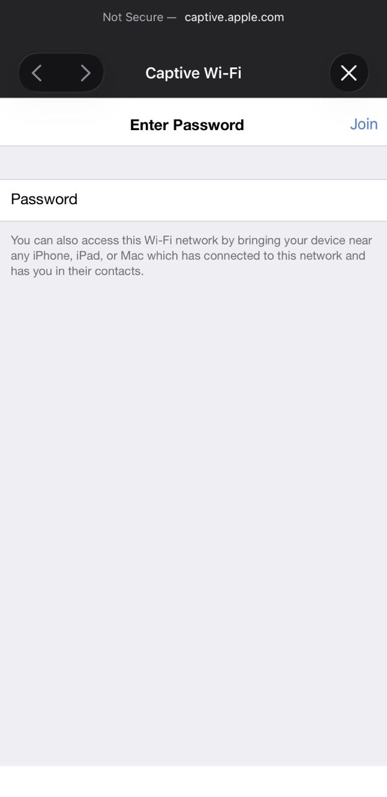
Step 4: Password Phished via Victim Entering
- The victim enters their password and clicks Connect (or OK).
- The data is sent via an unencrypted HTTP POST request to the attacker's server.
- Back in the attacker's terminal (Kali), Wifiphisher captures the request.
- In the terminal output, you will see the captured credentials:
POST request from 10.0.0.87 with wifiphisher-wpa-password=Passw0rd
- The WPA2 password has been successfully phished.
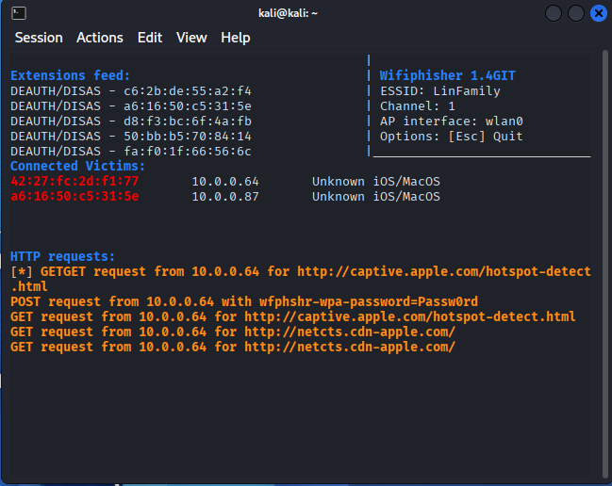t
Step 5: Cleanup (Post-Testing)
- Press Ctrl+C in the Wifiphisher terminal to stop the Evil Twin and deauthentication attacks.
- Shut down your wireless adapter to restore normal network operations.

⚠️ Important Disclaimer
This testing guide is strictly for educational and authorized penetration testing purposes only. You must have explicit written permission from the network owner to test this. Unauthorized use is illegal.

